**VMware Workstation User Guide**

**Eduardo Gallego Chillón – 2º DAW**

**IES Francisco Ayala (Granada)**

# **Contenido**

1. What is VMware Workstation? 2

2. System requirements 2

2.1. Non compatible processors 2

2.2. How to download VMware Workstation 2

3. Installing VMware workstation 3

# **What is VMware Workstation?**

VMware Workstation is a software that allows you to execute virtual machines on a computer with Windows or Linux operative system. These VM’s runs her own OS, and works simultaneously with the physical system.

Virtual machines are very useful, for example, for system administrators to check, verify and test the environment of clients and servers. Several VM’s can be run at the same time.

# **System requirements**

Recommended requirements for use VMware Workstation are:

* 64-bit AMD or Intel processor from 2011 or later, and Intel Core i7 and Xeon processors from 2010.
* 1.3 GHz or better core speed.
* 2 GB of RAM (4 GB recommended).
* 1.2 GB or more available disk space, and extra space for every virtual machine disk(s).

## **Non compatible processors**

* Intel Atom processors from 2011 and 2012.
* AMD processors from 2011.

## **How to download VMware Workstation**

VMware workstation can be downloaded from this official website. The URL for download is:

<https://my.vmware.com/en/web/vmware/info/slug/desktop_end_user_computing/vmware_workstation_pro/15_0>

In this page, you can choose the version and operative system that you use.

# **Installing VMware workstation**

These are the steps form installing VMware Workstation:

1. Execute the installer, then click Next button.

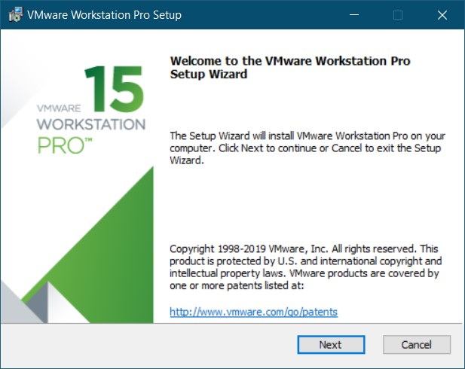

Figure 1. First installer's screen

1. Accept the terms and click Next.

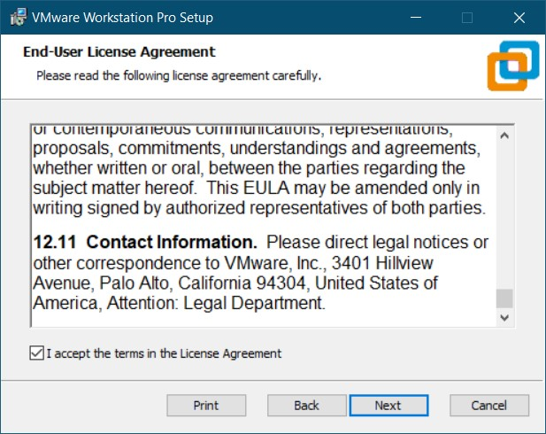

Figure 2. Accepting terms

1. In this point, you can choose the installation folder or use the default folder. Optionally, you can enable the Enhanced Keyboard (only for international keyboards with additional keys). Then click next.

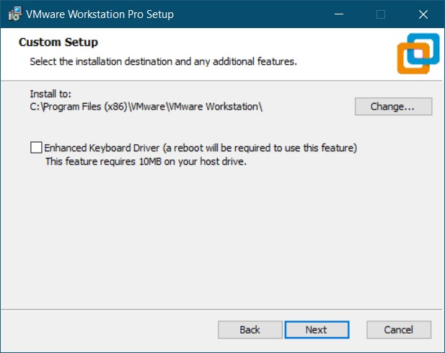

Figure 3. Customize setup

1. Enable first checkbox if you want to check updates on startup and click Next.

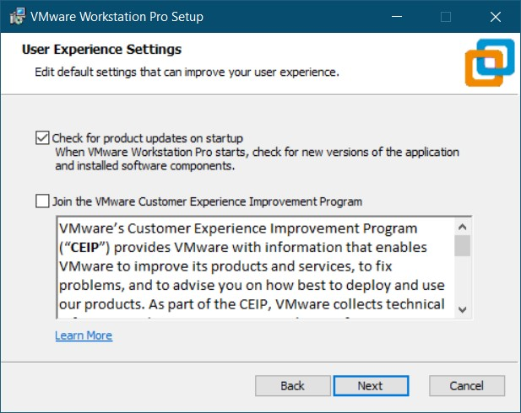

Figure 4. User experience settings

1. Create shortcuts on Desktop and/or on Start Menu Programs Folder if you want, and click Next.

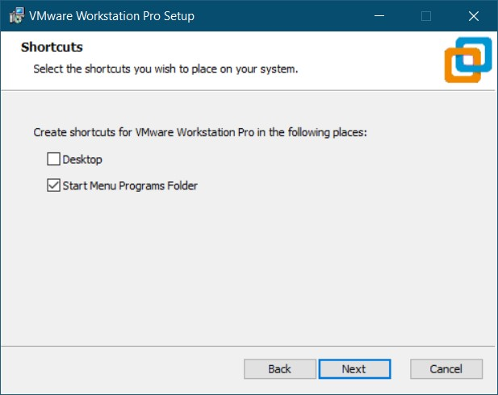

Figure 5. Create shortcuts

1. Click Install for begin the installation.

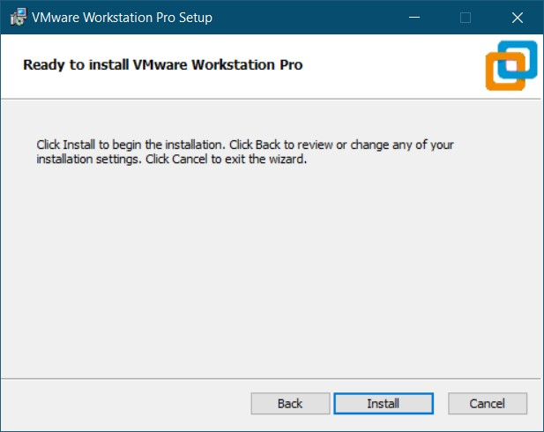

Figure 6. Begin the installation

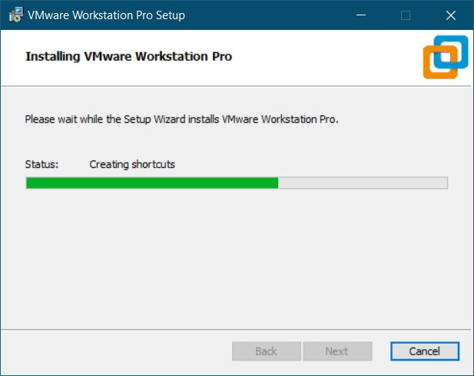

Figure 7. Installing WMware Workstation

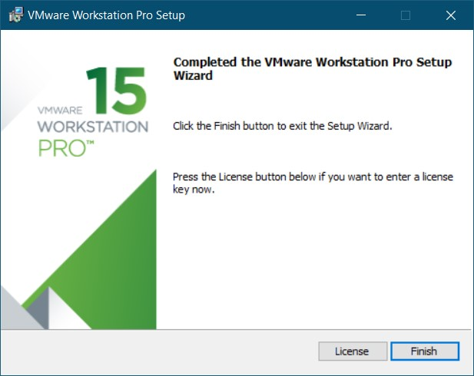

Figure 8. Installation finished

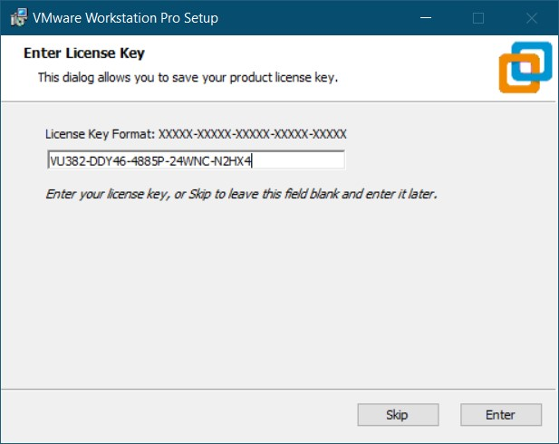

Figure 9. Entering license key

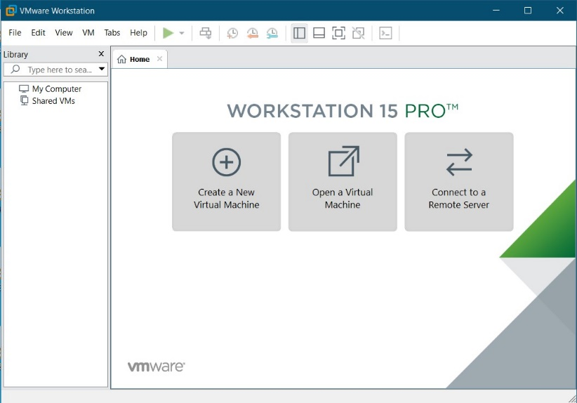

Figure 10. WMware Workstation home screen